LASC Level 1 Specification

Conformance Process for Specification and Acceptance Testing of LASC Communication Protocol
VERSION: [1.0] | REVISION DATE: [1/10/09]

Approver Name | Title | Signature | Date

Table of Contents
1. Introduction 4
1.1 EIP overview 4
1.2 EIP Objects 5
1.3 Session Overview 7
1.4 Message Protocol 7
1.5 NOP Command 9
1.6 ListServices Command 9
1.7 ListIdentity Command 11
1.8 RegisterSession Command 12
1.9 UnRegisterSession Command 13
1.10 SendRRData Command 13
1.11 SendUnitData Command 15
1.12 Full Message Layout 15
2. EIP server requirements 16
2.1 Mandatory Class Details 17
3. EIP client requirements 20
3.1 Base Ethernet communications 20
4. Testing Base Ethernet Communications 20
4.1 Test ICMP 20
4.2 Test UDP request/response 20
4.3 Test TCP request/response 20
4.4 Test 16 concurrent TCP connections 20
4.5 Test Cable Pull 21
5. Testing Encapsulation Commands 22
5.1 Test NOP (TCP) 22
5.2 Test List Identity (TCP or UDP) 22
5.3 Test RegisterSession (TCP) 22
5.4 Test UnRegisterSession TCP 23
5.5 Test ListServices (UDP or TCP) 23
5.6 Test SendRRData (TCP) 24
6. Testing Session Handling/message handling 25
5.7 Multiple sessions 25
5.8 Session Timeout 25
5.9 Message Handling 26
7. Testing Implementation of common services 28
6.1 Get Attribute Single 28
6.2 Set Attribute Single 28
8. Testing Implementation of Core Objects 29
5.10 EDS objects checked 29
9. Testing Error Codes 31
10. Timeout testing 31
11. Retest concurrent sessions 31
12. Appendix A– Data Sizes 32

Introduction
This document covers the requirements for a device (server) or client to meet LASC Level 1 compliance levels. This covers, in brief, the EIP (Ethernet/IP) stack (Layers 1, 2, 3/4) and a subset of the Application layer functionality (Layer 7). This is the full communication channel between LASC compliant modules.
This layer of certification is to ensure a basic level of information transfer between any server/client pair.
This document does not cover functionality or message responses outside the specific areas noted. That functionality is covered in the specific Level 2 specification for the device.

EIP overview
LASC communication protocol is built on the foundation of EIP and CIP. Full specifications may be obtained from ODVA; however this document defines the smaller subset of the requirements that must be implemented for LASC compliance.
The EIP protocol is designed for the exchange of time-critical application information. EIP makes use of standard Ethernet and TCP/IP technology to transport CIP (Control and Information Protocol) communications packets.
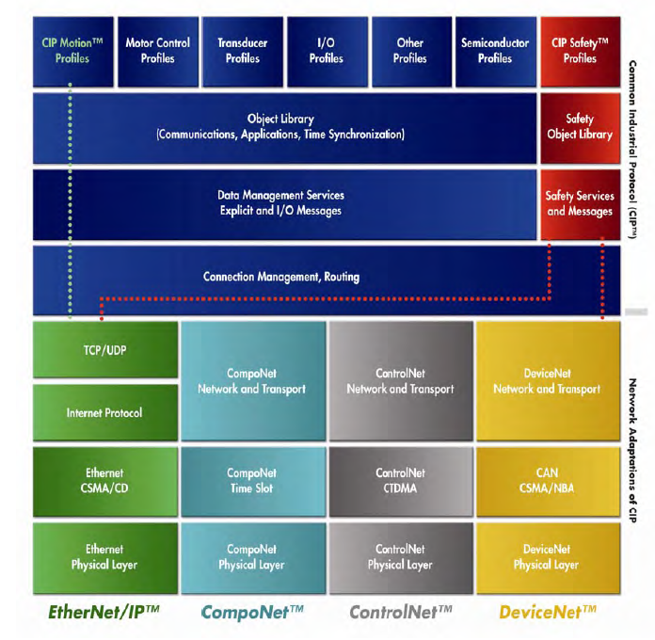
CIP is a peer to peer object oriented protocol that provides connection between devices and controllers

EIP Objects
An object consists of the following (See Figure 4-1.1):
- A set of closely related attributes (data)
- A set of behaviours (functionality)
- A set of services (common or object–specific)
- A set of connections.
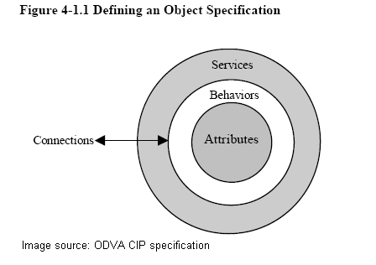
A Class Attribute is an attribute that is shared by all objects within the same class.
An Instance Attribute is an attribute that is unique to an object instance and not shared by the object class.
Common Services are those whose request/response parameters and required. Behaviours are defined in CIP Common Specification, Appendix A.
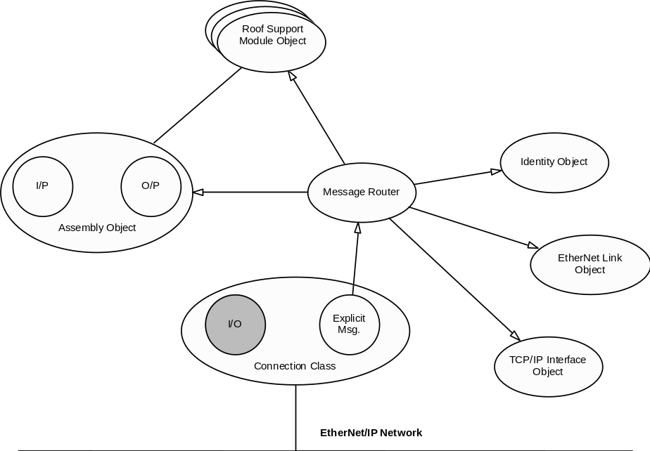A typical object model for a device will look generally like this:

Session Overview
The normal life of an EIP session would generally involve the following steps:
- A Client opens a TCP connection to <server IP address>, port 44818
- The client can send non-message commands (NOP,ListServices,ListIdentity etc)
- The server MUST respond to commands requiring a response with a message indicating status
- the client sends RegisterSession message
- the server responds with the session id to be used in all future messages
- The client uses SendRRData to encapsulate data/function requests
- the server responds to every message with a response indicating status, data etc
- When the client has finished, it sends an UnregisterSession message
- The client TCP connection can be closed

Message Protocol
While the CIP specifies both a ‘connected’ and ‘unconnected’ communication, the LASC standard is to use unconnected messages in all cases. These messages are unconditionally point to point.
There are 7 mandatory commands that must be implemented in all devices shown in the following table:
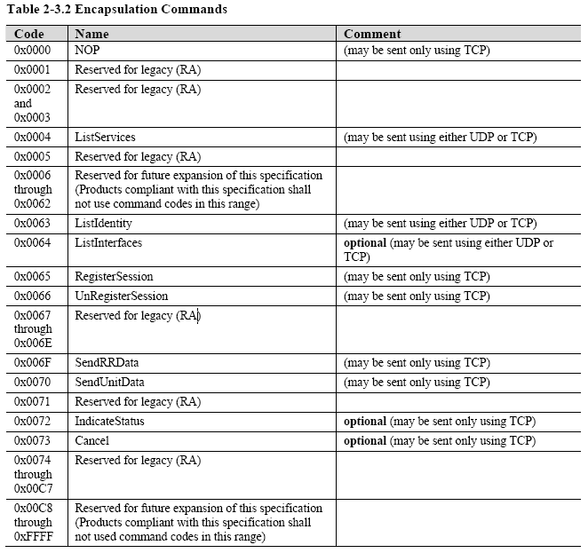
The other optional commands may be implemented. Every device shall accept commands that it does not support and return a ‘command not supported’ status code without breaking the session or TCP connection.
NOTE: Message structure items are coded in little endian unless specified otherwise.

NOP Command
The NOP command may be used to check TCP connection status. The client or server may generate this message. The receiver MUST not send any response to this message.
Message Structure
Field | Example (bold is mandatory) | Notes
CMD(2) | 0x0000 | NOP
Length (2) | 0x0000 | No data to be attached
Session handle (4) | 0x00000000 | Ignored
status (4) | 0x00000000 | Must be 0
Sender context (8) | 0x0000000000000000 | Ignored
Options (4) | 0x00000000 | Must be 0

ListServices Command
This command is used to determine which encapsulation service classes are supported. There is only one service class defined, so the response message is completely defined.
Message Structure
Field | Example (bold is mandatory) | Notes
CMD(2) | 0x0004 | List Services
Length (2) | 0x0000 | No data to be attached
Session handle (4) | 0x00000000 | Ignored
status (4) | 0x00000000 | Must be 0
Sender context (8) | 0x0000000000000000 | Any Sender context – usually message number
Options (4) | 0x00000000 | Must be 0

Response Structure
Field | Example (bold is mandatory) | Notes
CMD(2) | 0x0004 | List Services
Length (2) | 0x001a | Response data portion
Session handle (4) | 0x00000000 | Ignored
status (4) | 0x00000000 | Must be 0
Sender context (8) | 0x0000000000000000 | Preserved Sender context from request message
Options (4) | 0x00000000 | Must be 0
Item Count (2) | 0x0001 | 1 item
Item Type code (2) | 0x0100 | Communications service class
Item Length (2) | 0x0014 | Length of the item data
Version (2) | 0x0001
Capability flags (2) | 0x0020 | Supports TCP CIP
Name (16) | 434f4d4d554e49434154494f4e530000 | “Communications”

ListIdentity Command
This command may be issued by a client broadcast over UDP to determine available EIP servers on the network.
Message Structure
Field | Example (bold is mandatory) | Notes
CMD(2) | 0x0063 | Identity
Length (2) | 0x0000 | No data to be attached
Session handle (4) | 0x00000000 | Ignored
status (4) | 0x00000000 | Must be 0
Sender context (8) | 0x0000000000000000 | Must be 0
Options (4) | 0x00000000 | Must be 0

Response structure
Field | Example (bold is mandatory) | Notes
CMD(2) | 0x0063 | List Services
Length (2) | 0x002d | Response data portion
Session handle (4) | 0x00000000 | Ignored
status (4) | 0x00000000 | Must be 0
Sender context (8) | 0x0000000000000000 | Preserved Sender context from request message
Options (4) | 0x00000000 | Must be 0
Item count | 0x000x | Items to follow
Item type code (2) | 0x000c | Must be 0x0c
Item Length (2) | 0x00xx
Protocol version (2) | 0x0000 | Must be 0
Socket Address sin_family (2) | 0x0000 | All following items are defined in the EDS
Socket Address sin_port (2) | 0xaf12 | 44818 for EIP
Socket Address sin_address (4) | 0x7f000001 | Big-endian 127.0.0.1
Socket Address sin_zero (8) | 0x0000000000000000
Vendor id (2) | 0x0000 | 768 for CSIRO
Device type (2) | 0x0000
Product code (2) | 0x0000
Revision (2) | 0x0001
Status (2) | 0x0000
Serial Number (4) | 0x0000
Product name (8) | SPMS | From EDS
State (1) | 0x00

RegisterSession Command
This message is sent to commence a data transfer session.
Message Structure
Field | Example (bold is mandatory) | Notes
CMD(2) | 0x0065 | Register session
Length (2) | 0x0004
Session handle (4) | 0x00000000 | Ignored
Status (4) | 0x00000000 | Must be 0
Sender context (8) | 0x0000000000000000 | Any Sender context – usually message number
Options (4) | 0x00000000 | Must be 0
Protocol Version | 0x0001
Options Flag | 0x0000 | reserved

Response structure
Field | Example (bold is mandatory) | Notes
CMD(2) | 0x0065 | List Services
Length (2) | 0x0004
Session handle (4) | 0x000000xx | Session id to be used for all future messages
status (4) | 0x00000000 | Must be 0
Sender context (8) | 0x0000000000000000 | Preserved Sender context from request message
Options (4) | 0x00000000 | Must be 0
Protocol Version (2) | 0x0000 | Must be 0
Options Flags (2) | 0x0000 | Must be 0

UnRegisterSession Command
This message is sent to cease a data transfer session. Either an originator or a target may send this command to terminate the session. The receiver shall initiate a close of the underlying TCP/IP connection when it receives this command
Message Structure
Field | Example (bold is mandatory) | Notes
CMD(2) | 0x0066 | Register session
Length (2) | 0x0000
Session handle (4) | 0x00000000 | Ignored
status (4) | 0x00000000 | Must be 0
Sender context (8) | 0x0000000000000000 | Any Sender context – usually message number
Options (4) | 0x00000000 | Must be 0

There is to be NO response from this message

SendRRData Command
Message Structure
Field | Example (bold is mandatory) | Notes
CMD(2) | 0x006f
Length (2) | 0x0018
Session handle (4) | 0x00000001
status (4) | 0x00000000
sender context (8) | 0x0000000000000001
Options (4) | 0x00000000
Iface Handle (4) | 0x00000000
Timeout (2) | 0x0000
Item Count (2) | 0x0002
Address Type (2) | 0x0000
Address Length (2) | 0x0000
Data Type ID (2) | 0x00b2
Data Length (2) | 0x08
Service (1) | 0x0e
Path Size (1) | 0x03
Path (size*2) | 0x206424003003 | Class tag = 0x20  Class=0x64  Instance tag=0x24  Instance = 0  Attribute tag =0x30  Attribute = 3
Data (variable) | none

Response example for the above packet
 |  | Notes
CMD(2) | 0x006f
Length (2) | 0x0016
Session handle (4) | 0x00000001
status (4) | 0x00000000
sender context (8) | 0x0000000000000001
Options (4) | 0x00000000
Iface Handle (4) | 0x00000000
Timeout (2) | 0x0000
Item Count (2) | 0x0002
Address Type (2) | 0x0000
Address Length (2) | 0x0000
Data Type ID (2) | 0x00b2
Data Length (2) | 0x06
Service (1) | 0x8e | Note that the requested service is OR’d with 0x80 in the response
Reserved | 0x00
Status | 0x00
Additional status size | 0x00
Data (variable) | 0x7400 | The size of the data returned is DataLength-4-additionalStsSize*2

SendUnitData Command
This command is unused in the LASC subset of the EIP protocol. A Client should not send this message. A server should not reply to this message.

Full Message Layout
A full message including all the headers is as shown in the image below:
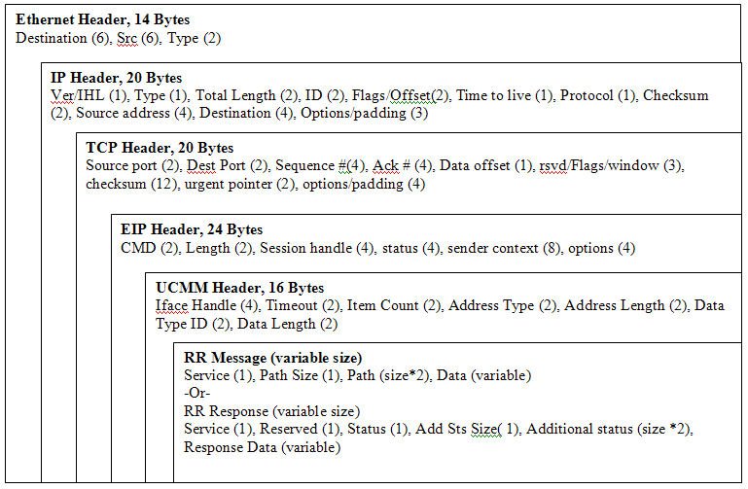
RR Messages have a fixed overhead of 113 bytes + variable size path + variable size data.
Responses have a fixed overhead of 115 bytes + variable size additional status + variable size data.

EIP server requirements
Level 1 compliance covers the basic communication protocols and required functionality for every device.
Every server implementation MUST have at least the following functionality:
- Base Ethernet communications, including
  - TCP/IP connection, including error handling and connection checking (RFC 793)
  - IP Version 4 (RFC 791)
  - UDP (RFC 768)
  - Address Resolution Protocol (ARP) (RFC 826)
  - Internet Control Messaging Protocol (ICMP) (RFC 792)
  - Internet Group Management Protocol (RFC 1112 + 2236)
  - IEEE 802.3 as defined in RFC 894
- Correct and valid responses to Encapsulation commands
- 0x0, NOP
- 0x4, List Services
- 0x63, List Identity
- 0x65, Register Session
- 0x66, Unregister Session
- 0x6f, Send RR Data
- 0x70, Send Unit Data
- Unconnected message handling Including error handling, message timeouts and status responses
- Implementation of core objects
- Class 0x01 (Identity Object)
  - Class Attribute 1 (Revision)
  - Instance Attributes 1-7
- Class 0xf5 (TCP/IP Interface Object)
  - Class Attribute 1 (Revision)
  - Instance Attributes 1-6
- Class 0xf6 (Ethernet link Object)
  - Class Attribute 1 (Revision)
  - Instance Attributes 1-3

- Implementation of common services
- 0x0e, Get Attribute Single
- 0x10, Set Attribute Single

- Implementation of error responses
- 0x0, success
- 0x1, invalid command
- 0x3, incorrect data
- 0x64, invalid session handle
- 0x65, invalid length
- 0x69, unsupported command revision

- Implementation of message forwarding
- EDS description file for compliance testing.

Other functionality may be described in the Level 2 components of the device specifications.

Mandatory Class Details

Identity Object
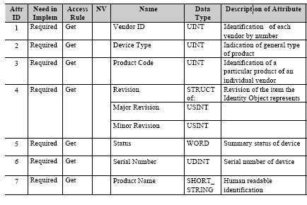
Vendor shall be 768
Device type shall be 100
The other details shall be vendor-specific and entered in the EDS for the device

TCP object
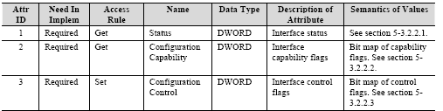
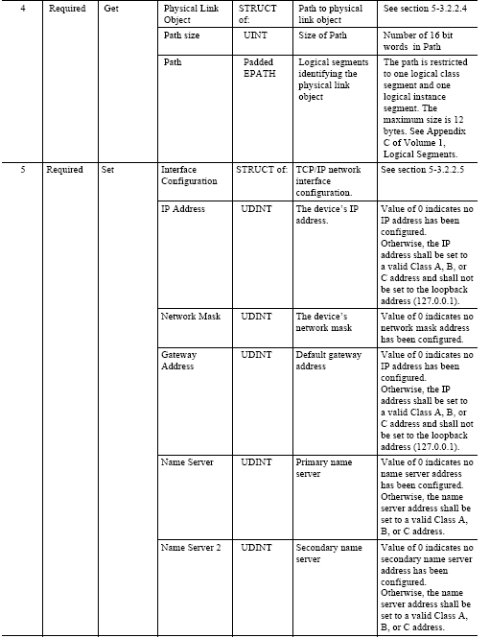
The mandatory information in the EDS for this class will be the IP Address, coded in dotted string (e.g. 10.0.0.10) in Attribute 5.

Ethernet object
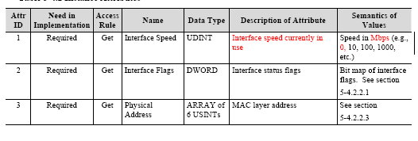

EIP client requirements
Every client implementation MUST have at least the following functionality:

Base Ethernet communications

TCP/IP connection, including error handling and connection checking (RFC 793)
IP Version 4 (RFC 791)
UDP (RFC 768)
Address Resolution Protocol (ARP) (RFC 826)
Internet Control Messaging Protocol (ICMP) (RFC 792)
Internet Group Management Protocol (RFC 1112 + 2236)
IEEE 802.3 as defined in RFC 894

Testing Base Ethernet Communications

Test ICMP
The device is to be issued an ICMP (ping) message. The device should respond with its IP address. The round trip time should be less than 10ms.

Test UDP request/response
UDP is tested by sending a ListIdentity command (0x0063) via UDP, the device should respond with a valid ListIdentity response. The details for the ListIdentity packet should match the details coded in the EDS file supplied with the device.

Test TCP request/response
The TCP connection is tested by sending the ListIdentity command (0x0063) via TCP. The device should respond with a valid ListIdentity response, with values populated as per the EDS file provided with the device.

Test 16 concurrent TCP connections
16 concurrent TCP connections are to be simultaneously established by connecting to port 44818 of the device. Once these connections are established each connection is to have a Register Session command (0x0065) issued via TCP. Each of the sessions will respond with valid connection details. All responses should be identical to that of the tests above. The connections should now be closed.

Test Cable Pull
2sec / 120sec resume (for these tests there will be a network switch between the PC and the device being tested)

The user will be prompted by the testing software to remove the Ethernet cable for 2 seconds. The cable is to be disconnected directly from the device under test. After a 2 second pause the cable it to be re-inserted.

The user will be prompted by the testing software to remove the Ethernet cable for 120 seconds. The cable is to be disconnected directly from the device under test. After the 120 second pause the cable is to be re-inserted.

The user will be prompted by the testing software to remove the Ethernet cable for 2 seconds. The cable is to be disconnected directly from the PC. After a 2 second pause the cable it to be re-inserted.

The user will be prompted by the testing software to remove the Ethernet cable for 120 seconds. The cable is to be disconnected directly from the PC. After the 120 second pause the cable is to be re-inserted.

Testing Encapsulation Commands

Test NOP (TCP)
The NOP command may be used to test the underlying TCP connection without breaking any existing EIP session. The NOP may be sent by either the client or the server. There is no response to the NOP command.

Prerequisites: No EIP session. Send a NOP message and ensure no response is received.

Prerequisites: EIP session registered. Send a NOP message and ensure no response is received.

Test List Identity (TCP or UDP)
The ListIdentity message is sent by a client to identify EIP devices available. When sent as a UDP message, it is a broadcast to identify all devices on the subnet. When sent via TCP, it may be used to list the parameters of the device connected on the current TCP connection.
In all the tests below, each of the data items should be checked against the EDS for validity.

Prerequisites: No EIP session. Send a ListIdentity message via UDP. Ensure DUT responds with valid ListIdentity response.

Prerequisites: NO EIP session. Send a ListIdentity message via UDP broadcast. Ensure DUT responds with valid ListIdentity response.

Prerequisites: TCP communications channel. Send a ListIdentity message via TCP. Ensure DUT responds with valid ListIdentity response.

Test RegisterSession (TCP)
The RegisterSession message is used to commence a session between the client and the server. No messages other than NOP and ListIdentity may be validly used before the session has been started.
Where a response is received, the following items should be validated: Sender context, session handle, status and

Prerequisites: No EIP session. Send a RegisterSession message via UDP. Ensure no response is received

Prerequisites: No EIP session. Send a RegisterSession message via TCP. Ensure a valid response is received.

Prerequisites: No EIP session. Send a RegisterSession message via TCP with Protocol version 2. Ensure a valid response is received with status 0x69 and highest supported version in Protocol version field

Test UnRegisterSession TCP
The Unregister session is used to terminate the current session. The session is also closed when the TCP connection is lost. There is no response to this message

Prerequisites: No EIP session. Send an UnRegisterSession message. No response

Prerequisites: EIP session. Send an UnRegisterSession message. No response.

Prerequisites: EIP session. Send an UnRegisterSession message. Send another message with same session if. Error response

Prerequisites: No EIP session. Send an UnRegisterSession message with wrong session id. No response. Send other message with correct session id. Should still respond ok.

Test ListServices (UDP or TCP)
The ListServices message is used to identify which encapsulation service classes are supported (not the Explicit Messaging services such as Get_Attribute_Single) Currently, only one service is defined by EIP and it indicates that the device supports encapsulation of CIP packets.

Prerequisites: No EIP session. Send a ListServices message via UDP. Valid reply message from DUT.

Prerequisites: No EIP session. Send a ListServices message via TCP. Valid reply message from DUT.

Prerequisites: EIP session. Send a ListServices message via UDP. Valid reply message from DUT.

Prerequisites: EIP session. Send a ListServices message via TCP. Valid reply message from DUT.

Test SendRRData (TCP)
This message is the main transfer of encapsulated request/reply packets between the client and server. This message, for Landmark compliance purposes, is used solely to transfer UCMM (unconnected) messages as per the format described in section 1.10.
Details of required data for UCMM testing is in section 9.

Prerequisites: No EIP session. Send a SendRRData message via TCP. With class: 1, instance: 1, attribute: 1, service: 14. No reply message from DUT.

Prerequisites: EIP session. Send a SendRRData message via TCP. With class: 1, instance: 1, attribute: 1, service: 14. Valid reply message from DUT.

Testing Session Handling/message handling
This section describes the testing required to ensure that the device or application under test correctly handles messages and sessions.

Multiple sessions

Test 16 registered sessions simultaneously – each session should be given a unique session id.

Test RRData in each connected session – each message should receive a valid response, including correct session id and message context

Session Timeout

Test connected session timeout with no messages – the session should not have disconnected after 2 seconds.

Test connected session timeout with no messages – the session should have disconnected after 120 seconds.

Message Handling

Send truncated message, test message timeout – no response received.

Send Long messages (dual message), check response received for both messages – should receive valid responses.

Send garbled message (shorter than normal packet) – should get an error return

Send garbled message (same size as normal packet) – should get an error return

Send garbled message (longer than normal packet) – should get an error return

Send 1000 EIP messages with no wait time (stress test) –should get valid responses for each message

send messages with wrong session identifier – should get error message.

send messages with negative/same sender context – should get sender context copied and returns no error

send messages with previous (and closed) session handle -should get error message

send register, TCP fail then reconnect (cable pull pc side), messages should fail

send register, TCP fail then reconnect (cable pull pc side), unregister message should fail

send register, TCP fail then reconnect (cable pull device side), messages should fail

send register, TCP fail then reconnect (cable pull device side), unregister message should fail

send messages: nop, register, nop, listservices,nop, unregister – test nop does not interfere with normal operation

Testing Implementation of common services

Get Attribute Single
Class 1, instance 1, attribute 1 is read using SendMessage

Set Attribute Single
This will involve the write of an attribute.

Testing Implementation of Core Objects

EDS objects checked
Each Attribute in the EDS file for the device is checked for a valid response from the device.
If the attribute is implemented, then the General Status response should be 0x00 (Success). If the attribute is not implemented, then the General Status Response should be 0x05 (PATH destination unknown). If the attribute is not part of the object definition then the General Status Response should be 0x14 (Undefined attribute). If the proper General Status Response of 0x00 (Success) is returned then the size of the attribute is verified as well as its value.

The EDS file should consist of at least the following.

Identity Object

Test Attribute 1: Vendor Id

Test Attribute 2: Device Type

Test Attribute 3: Product Code

Test Attribute 4: Revision

Test Attribute 5: Status

Test Attribute 6: Serial Number

Test Attribute 7: Product name

TCP/IP Object (Class Code 0xf5)

Test Attribute 1: Revision (implemented)
For instance 1:

Test Attribute 1: Status

Test Attribute 2: Configuration Capability

Test Attribute 3: Configuration control

Test Attribute 4: Physical Link Object

Test Attribute 5: Interface Configuration

Test Attribute 6: Host Name

Test Attribute 7-99 (optional)
For instance 2:

Test Attribute 1, response should be 0x5 (path destination unknown)

Ethernet Link (Class Code 0xf6)

Test Attribute 1: Revision (implemented)

For instance 1:

Test Attribute 1: Interface Speed

Test Attribute 2: Interface Flags

Test Attribute 3: Physical address

Test Attribute 4-99 (optional)

Testing Error Codes
The correct error code should be provided in the status code field in the following situations
Error 0x1: invalid or unsupported encapsulation command
Error 0x3: Poorly formed or incomplete data in the data portion
Error 0x5: Path destination unknown
Error 0x64: invalid session handle
Error 0x65: invalid length message
Error 0x69: unsupported encapsulation protocol revision

Timeout testing
List Identity Response/UDP < 250ms
List Services Response/TCP (assuming existing TCP connection)< 250ms
Unconnected explicit response - TCP connection established (Specific internal object/attribute would be tested)< 100ms
Two back-to-back explicit message requests without dropping either > 1ms

Retest concurrent sessions
16 concurrent TCP connections are to be simultaneously established by connecting to port 44818 of the device. Once these connections are established each connection is to have a Register Session command (0x0065) issued via TCP. Each of the sessions will respond with valid connection details. All responses should be identical to that of the tests above. The connections should now be closed.

Appendix A– Data Sizes
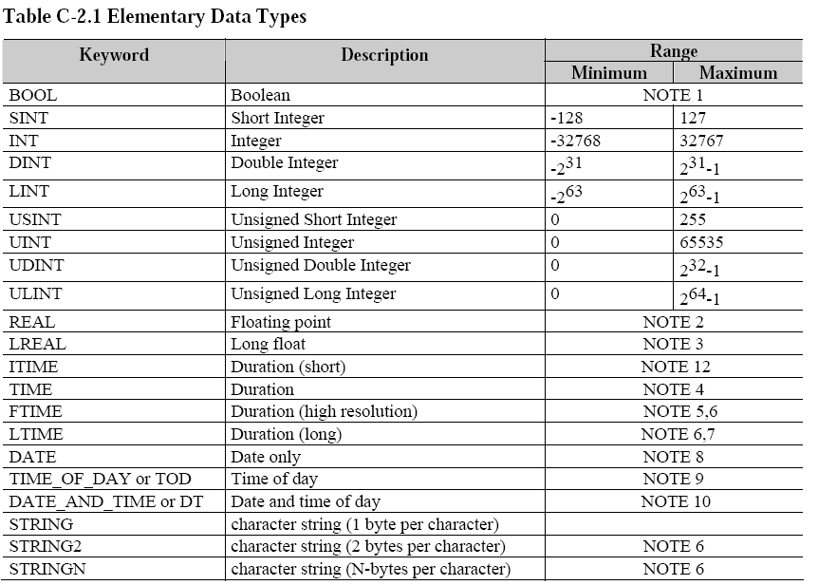

Version | Description of Change | Author | Date
1.0 | Created | Mark Dunn | 4/2/08


